**Adelo**

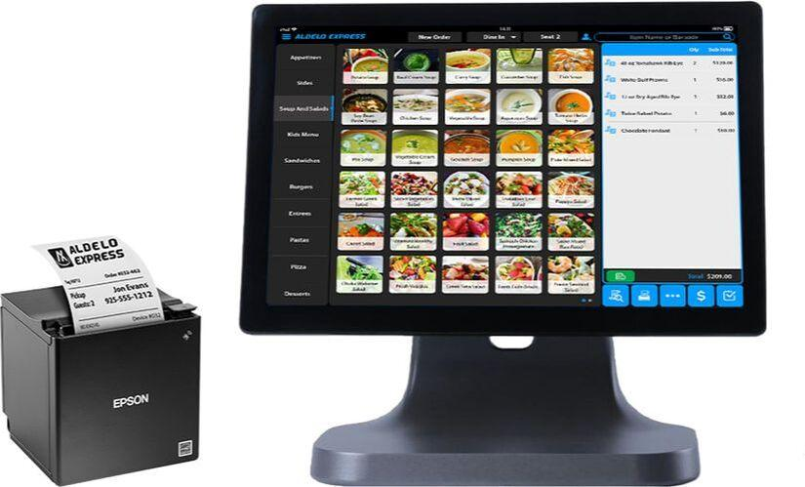

* Affordable
* Front of House Reliable
* Customer Service
* Basic Needs Feathers