**Dejavoo**

* **Clover**

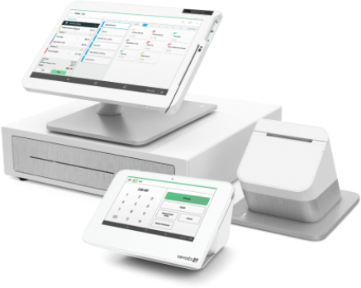

### **Payment Processing**

### **Inventory Management**

### **Order Management**

### **Employee Management**

### **Reporting & Analytics**

### **Customization Options**

* **QD2**

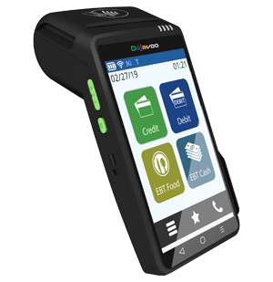

### **Wifi / Bluetooth / 4G**

### **5 inch Touch Screen**

### **E SIM world coverage**

* **4V, 2 x 2600mAh batteries**
* **All-In-One DejaPayPro**
* **QD4**

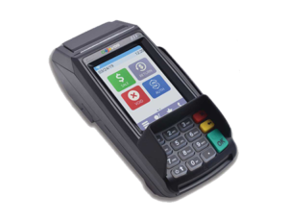

### **Large Touch Screen**

* **Ethernet / WiFi / USB**
* **Contactless**
* **Fast**