**POS**

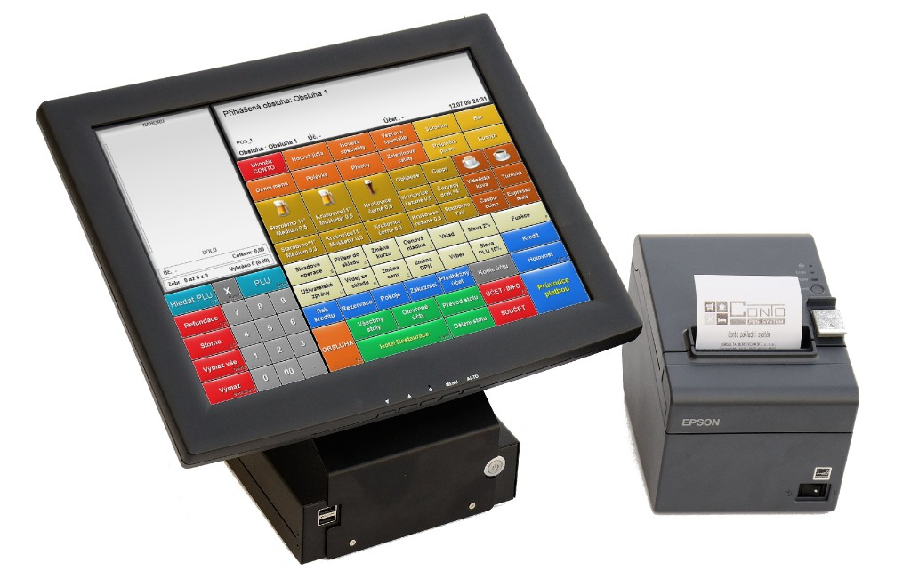

* **Extensive Functionality**
* **Customization**
* **Powerful Reporting:**
* **Integration Capabilities:**
* **Scalability**