**PAX**

* **a920**

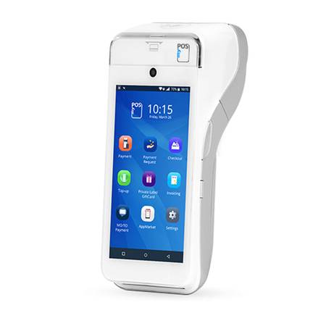

* **WiFi / Bluetooth / 4G**
* **Camera**
* **10 hour Battery**
* **Large Touch Screen**
* **Contactless**
* **Electronic signature capture**
* **Fast**