**HotSauce**

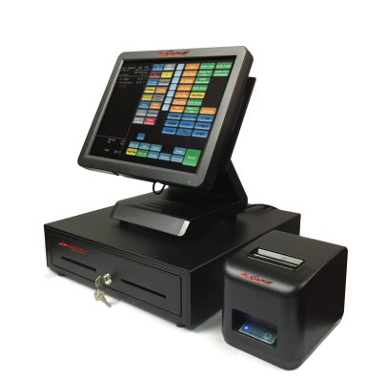

* User-Friendly Interface
* Customizable
* Quick Order Entry
* Menu Modifions
* Consumer Service